PRESS RELEASE

Actual coverage volume quantifiable for the first time

New practical demonstration method "3D-Coverage" from Pfannenberg creates certainty for the planning and development of signaling solution projects

Hamburg, 28 November 2017. Electro-technology specialist Pfannenberg is the first manufacturer to present a practical method for demonstrating the effective performance of audible and visual signaling devices in a given space. It provides designers and safety officers with reliable information about the size of the area actually covered by the signaling devices. This demonstration method offers protection from incorrect dimensioning, reliable compliance with industrial norms and regulations and optimum cost and energy efficiency. Using these new parameters as a basis, the company has also thoroughly redesigned its Pfannenberg Sizing Software (PSS) planning tool so that users can find their ideal signaling solution even more easily. With solution-oriented advice from Pfannenberg, users can improve their competitiveness with more effective planning, increased machine availability and a significantly lower risk of accidents.

Mark Egbers, Industry Group Manager Infrastructure at Pfannenberg, commented:
"The perception of audible signals depends crucially on the space in question and on the level of ambient noise. Anyone responsible for designing reliable signaling solutions needs to be certain about the area actually covered by the signal. The information traditionally found on the data sheets provided by many manufacturers does not allow any conclusions to be drawn about the actual performance of a product in a given space. 3D-Coverage shows this data clearly and helps users to find a safe solution, to choose the right products and to save costs with correct dimensioning."

Device performance for a given space visualized
Pfannenberg's 3D-Coverage uses an innovative demonstration method to visualize and compare the actual performance of signaling devices in a given space under the real environmental conditions surrounding the application and dictated by the type of alerting system. For example, it allows the coverage volume of audible signaling devices to be calculated after consideration of the ambient noise in dB(A) and the signal tone (e.g. DIN tone) and an offset of ∆10 dB(A) in relation to the height, width and length of the space throughout which the signal is to be heard or seen. For the visual signaling devices, the performance data is given commensurate with informing, warning and alerting (EN-54-23) applications.

Effectiveness in an emergency is crucial
In many safety-related areas, norms and regulations require that visual and/or audible signaling devices are used – in fire and gas alerting, for example, or workplace and machine safety. The greater the safety-related function of a signaling device in the application, the more important the actual coverage volume. Particularly in an alerting application, this can be of crucial, even vital, importance. Workers today are faced with increasing sensory overload as the result of the many operational signals present at their workplace. This makes it more difficult for them to perceive alarm signals and to interpret them correctly so the careful choice of a signaling solution is even more important.

Addressing the core problem
Up to now there have been no concrete specifications in Germany for the efficiency of signaling solutions. As signaling devices initially look very similar and the relevant product data sheets generally offer too little in the way of orientation, the purchase price becomes in many cases the most important selection criterion – with high-risk consequences. In many cases, inappropriate signaling devices are installed in order to comply with the vaguely formulated minimum requirements. The resulting systems are often under-specified, presenting a safety risk, or over-specified, resulting in unnecessarily high costs. The danger is that the sub-optimum performance of the signaling device will only be discovered when danger really threatens.

Those responsible for operations are risking the health of their staff and costly damage to buildings, machines, systems and processes.

New version of the Pfannenberg Sizing Software (PSS)
In order to provide the best support for the new 3D-Coverage concept, enhancements have been made to PSS, the tested, cost-free and user-friendly online planning tool. It calculates not only individual values but also provides an instant, informed recommendation for the optimum signaling devices and their positioning. Taking individual environmental conditions into account in this way, users can avoid expensive over-specification and risky under-specification at the planning stage or when they review the configuration.

Photo caption:

Photo caption_Image 1: Pfannenberg's 3D-Coverage: a new method for visualising the actual performance of signaling devices in a given space.
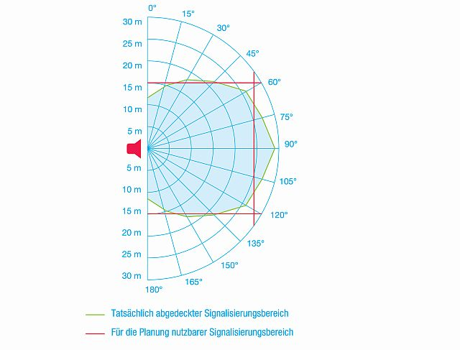
Photo caption_Image 2: 3D-Coverage shows that the information traditionally supplied on technical data sheets by many manufacturers does not allow any conclusions to be drawn about the actual performance of a product in a given space

About Pfannenberg
Pfannenberg is a medium-sized company which provides innovative and high-quality electro-technology for industry. Today, the company belongs to the global players of this industry with its headquarters is in Hamburg, Germany and its locations in Brazil, China, England, France, Italy, Russia, Singapore and the USA. The product portfolio comprises components and system solutions for the thermal management of electrical enclosures, chillers, visible and audible signaling technology and custom solutions. A special highlight in the Pfannenberg portfolio is the designed illuminations which are commissioned by architects, designers, and urban and spatial planners (www.art-illumination.com).
You can find more information about Pfannenberg on: http://www.pfannenberg.com

Press office
Carsten Otte
c/o Technical Publicity
Bäckerstraße 6, 21244 Buchholz
Tel. +49 (0)4181 968 098-80
cotte@technical-group.com

Company contact
Ulla Wenderoth
Pfannenberg Europe GmbH
Werner-Witt-Str. 1, 21035 Hamburg, Germany
Tel. +49 (0)40-73412-317
Ulla.Wenderoth@Pfannenberg.com

