PRESS RELEASE

One light, many possibilities

QUADRO LED-HI – the multifunctional light for industrial applications

Hamburg, 28 November 2017. At the Security 2016 trade fair in Essen, Pfannenberg presented the new QUADRO LED-HI multifunctional light, the successor to the tried and tested QUADRO LED-Flex. The QUADRO LED-HI is used for the visual signaling of hazardous situations and to indicate the status or fill level of machines and systems. Possible areas of application include the operation of industrial machines and systems, building safety and controlling traffic on factory premises. The optical signals of the lights are created with LEDS with a high level of luminous efficacy. Thanks to robust mechanical construction and categorisation in high protection classes (IP66, IP67 and IK08), the Quadro LED-HI is suitable for indoor and outdoor use. Modular in design and multifunctional, they offer manufacturing companies, industrial installation and service firms, mechanical and systems engineering companies and the producers of lifting equipment and their service departments a cost-efficient, versatile and powerful signaling solution.

"The Quadro LED-HI has everything an industrial light needs: not only high light intensity but also wide coverage volume thanks to its well-thought-out design. Furthermore, it is extremely robust. Neither aggressive environmental conditions nor driving rain nor condensation can impair its performance. With many functions and combination options, industrial companies can cover a wide range of applications with one flexible lighting solution which can be adapted to their requirements," says Carsten Hippler, Product Sales Manager Signaling at Pfannenberg.

Powerful signaling
The luminosity of the Quadro LED-HI can be adjusted up to 75 cd. However, luminosity is not a sufficient measure of the effectiveness of a signaling device. The actual coverage volume under real environmental conditions is much more decisive and this has been shown for the first time with Pfannenberg's practical demonstration method 3D Coverage. This takes account of factors such as the type of alert and the positioning of the device. This method indicates that, used with a clear cover, the coverage volume of the Quadro LED-HI is as follows (width/height/depth): Information applications - 49.5 m x 47.5 m x 36 m; warning applications - 22 m x 21 m x 16 m and alerting applications 11 m x 10.5 m x 8 m.

Versatile in use
Users can adjust the operating modes of the LED light at any time within a flexible range of options: continuous, blinking frequencies at 1 Hz /2 Hz and flashing frequencies at 0.1Hz / 0.5 Hz / 0.75 Hz / 1 Hz /2 Hz. The Quadro LED-HI is even more versatile used with a multi-voltage power pack. There is a 24 V variant with a functional range of 11 V to 60 V (DC) and a 230 V variant with a functional range of 90 V to 253 V (AC) at 50 Hz/60 Hz. The lights are also equipped with an inrush current limiter. The Quadro LED-HI is designed for ambient temperatures ranging from -40°C to +55°C.

Photo caption:
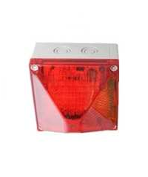
Photo caption_Image 1: New at Security 2016: The multifunctional Quadro LED-HI light for industrial applications
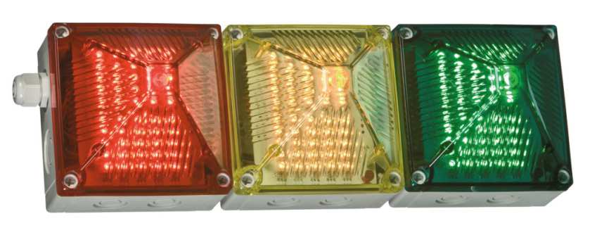
Photo caption_Image 2: Using terminals, the housing of Quadro LED-HI units can be daisy chained so that users can create different combinations of colours as required

About Pfannenberg
Pfannenberg is a medium-sized company which provides innovative and high-quality electro-technology for industry. Today, the company belongs to the global players of this industry with its headquarters is in Hamburg, Germany and its locations in Brazil, China, England, France, Italy, Russia, Singapore and the USA. The product portfolio comprises components and system solutions for the thermal management of electrical enclosures, chillers, visible and audible signaling technology and custom solutions. A special highlight in the Pfannenberg portfolio is the designed illuminations which are commissioned by architects, designers, and urban and spatial planners (www.art-illumination.com).
You can find more information about Pfannenberg on: http://www.pfannenberg.com

Press office
Carsten Otte
c/o Technical Publicity
Bäckerstraße 6, 21244 Buchholz
Tel. +49 (0)4181 968 098-80
cotte@technical-group.com

Company contact
Ulla Wenderoth
Pfannenberg Europe GmbH
Werner-Witt-Str. 1, 21035 Hamburg, Germany
Tel. +49 (0)40-73412-317
Ulla.Wenderoth@Pfannenberg.com

