PRESS RELEASE

Strong and stable: DNV-GL-certified signaling devices from Pfannenberg are guaranteed to perform reliably under tough conditions in harsh environments

They are ideally suited for demanding applications in any industry

Hamburg, 28 November 2017. DNV-GL-certified signaling devices from the electro-technology specialists Pfannenberg are the right solutions for tough industrial applications where they will be exposed to strong vibration, continuous jarring or heavy impact. Sectors where this might be the case include heavy industry, automobile manufacture, docks and shipyards, warehousing, transport and in processing facilities for the construction, timber, glass and pharmaceuticals industries. For example, the devices can be used in or around filling and sorting systems, cranes, foundries, steel mills, power stations, conveyors and production lines, silos, pipelines, gates, railways or with moveable heavy-duty shelving.

Det Norske Veritas (DNV) and Germanischer Lloyd (GL) certifications are primarily known from the maritime sector where they together form a world-leading classification company – DNV GL. The certificates are not only a fundamental requirement to allow electrotechnical components such as signaling devices to be operated on ships but also serve as a quality mark for robustness and reliability. This is underpinned largely by strict evaluation criteria and sophisticated testing procedures.

Anything that stands fast in heavy seas can also meet the demands of heavy industry
Signaling devices from Pfannenberg deliver an impressive performance not only in the maritime sector but also in many extremely tough industrial environments. DNV-GL-certified devices include the DS-series sounders, the flashing XENON lights in the PMF-series, the PAX flashing sounders in the PATROL series, the flashing lights in the WBL/WBS, ABL/ABS and WBLR/WBSR series and the Ex-ATEX flashing lights in the CWB-series. In the Germanischen Lloyd vibration tests, the signaling devices might be exposed to stresses up to 2.4 G, depending on the test method used. The award of a DNV-GL certificate guarantees the highest quality and reliability. For example, the sound from the audible signaling devices can carry over the high ambient noise levels generated by production processes and also penetrate acoustic obstacles effectively, ensuring that the workforce is warned or alerted.

No job is too tough, too dusty or too wet
The certification confirms that the signaling devices are impervious to vibration, jarring and impact. Their PCB components are attached very firmly to prevent damage from vibration. Metal support brackets reliably absorb or attenuate oscillation and vibration. Even without a protective cage, they resist high levels of mechanical stress and are guaranteed to function reliably at all times. Furthermore, torsion-resistant plastic housing with impact resistance level IK08 and high protection classes IP66 or IP67 not only guarantees maximum robustness and resistance to impact and shock, it is also dust-tight and can cope with hose water and limited periods of flooding. The devices are therefore also suitable for highly sophisticated applications in which raw materials are broken up, where a process creates dust, vapor or steam or where work and production areas are regularly pressure-cleaned with water.

"In many applications, for example in heavy industry and manufacturing plants, in logistics or in rail and goods transport, signaling devices are often exposed to extreme conditions," explains Carsten Hippler, Sales Product Manager Signaling at Pfannenberg. "We are proud that our DNV-GL-certified signaling devices are tough enough even for these demanding situations. The certification confirms unequivocally for every user and operator that they are highly reliable and of outstanding quality. We guarantee them for 10 years".

Furthermore, with the help of the user-friendly Pfannenberg Sizing Software (PSS), users can select the signaling solution that is appropriate to their needs, enabling them to avoid expensive over-specification and risky under-specification at the planning stage or when reviewing a configuration.

Photos and photo captions:

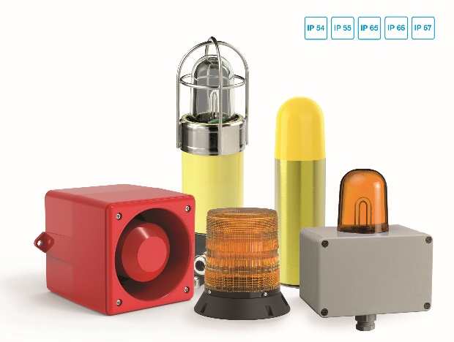
Photo caption_Image 1: Pfannenberg's wide range of DNV-GL-certified signaling devices are suitable for many different applications requiring devices in a high IP class.

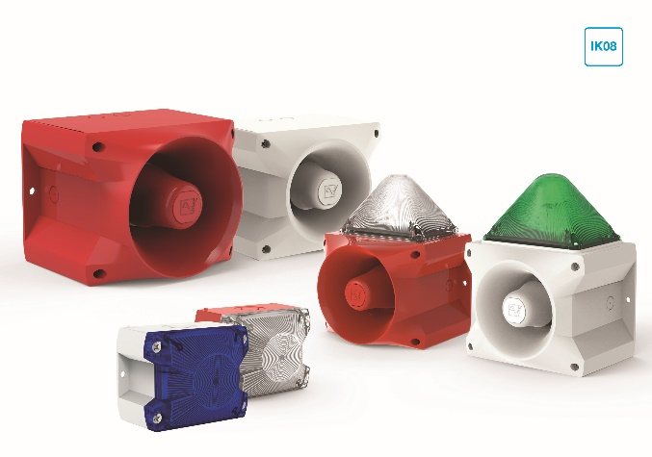
Photo caption_Image 2: Thanks to their torsion-proof plastic housing with impact resistance up to IK08 level, the DNV-GL signaling devices are particularly robust.

Photo caption_Image 3: Pfannenberg Sizing Software helps planers and users to select the correct signaling devices so that they are protected from over-specification or risky under-specification

About Pfannenberg
Pfannenberg is a medium-sized company which provides innovative and high-quality electro-technology for industry. Today, the company belongs to the global players of this industry with its headquarters is in Hamburg, Germany and its locations in Brazil, China, England, France, Italy, Russia, Singapore and the USA. The product portfolio comprises components and system solutions for the thermal management of electrical enclosures, chillers, visible and audible signaling technology and custom solutions. A special highlight in the Pfannenberg portfolio is the designed illuminations which are commissioned by architects, designers, and urban and spatial planners (www.art-illumination.com).
You can find more information about Pfannenberg on: http://www.pfannenberg.com

Press office
Carsten Otte
c/o Technical Publicity
Bäckerstraße 6, 21244 Buchholz
Tel. +49 (0)4181 968 098-80
cotte@technical-group.com

Company contact
Ulla Wenderoth
Pfannenberg Europe GmbH
Werner-Witt-Str. 1, 21035 Hamburg, Germany
Tel. +49 (0)40-73412-317
Ulla.Wenderoth@Pfannenberg.com

