PRESS RELEASE

A new type of connection for air/water heat exchangers from Pfannenberg

Top-mounted water connection facilitates planning and system changes.

Hamburg, 28 November 2017. Electronics specialists Pfannenberg will be presenting new air/water heat exchangers with a top-mounted water connection, and suitable for partially recessed positioning, at the SPS IPC Drives trade show in Nuremberg (Hall 5, Stand 339) this year. PWS 6502 T and PWI 6502 T devices have an output up to 5 kW. Even if this output is not used to capacity, they can achieve very effective cooling with in-feed water at a high temperature. The special feature is a new type of connection which is top-mounted to allow planners of workshops and production floors greater flexibility and to keep the cost of renovation works down.

Improved operating safety
Traditionally, water connections were usually fitted at the base of a device. In modern factories, they are now often situated at a height of two meters. Pipes laid higher up are better protected from operations at ground level where they could be damaged by forklifts or by people moving around, for example. This risk is avoided by the new position of the connections.

Easier planning
The T (for top-mounted) water connection is furthermore very suitable for intelligently planned production halls. The floor is kept clear and it is easier to make structural changes at ground level, for a new production line, for example. There is no need to reroute the pipework extensively each time. Supplying water from above permits not only better use of the available space, but is also more sustainable. It saves planners a great deal of effort and allows them to work more flexibly. At the same time, machine availability increases with the renovation work.

Energy-saving mode and the Multimaster controller
The heat exchangers are fitted optionally with an energy-saving mode (ESM) which allows the fans to be switched off temporarily when the devices are idling, cutting the energy they consume. The Multimaster function on the controller which is also available allows intelligent networking, even if it is not fitted to all the heat exchangers at a production site. By allowing several cooling devices to operate simultaneously, it ensures that the temperature even in large groups of electrical enclosures remains constant.

Partial recessing and the connection kit.
Model PWS 6502 T is designed for side-mounting and the PWI 6502 T version is designed to be partially recessed and side-mounted. A special kit with cover panels ensures that the partially recessed PWI heat exchanger blends with the design of the machine. The top-mounted water connection can be elegantly concealed with a connection kit. It can be configured both for the left and the right, or can be altered from top right to top left. The kit contains a cover with a bracket, quick-fit couplings, hydraulic hoses and the required insulation.

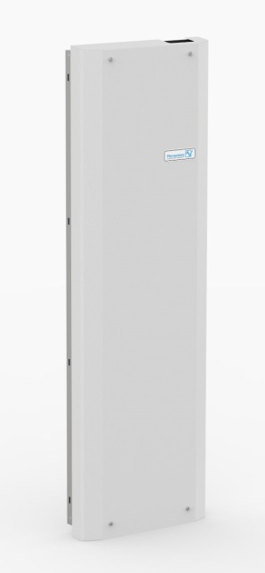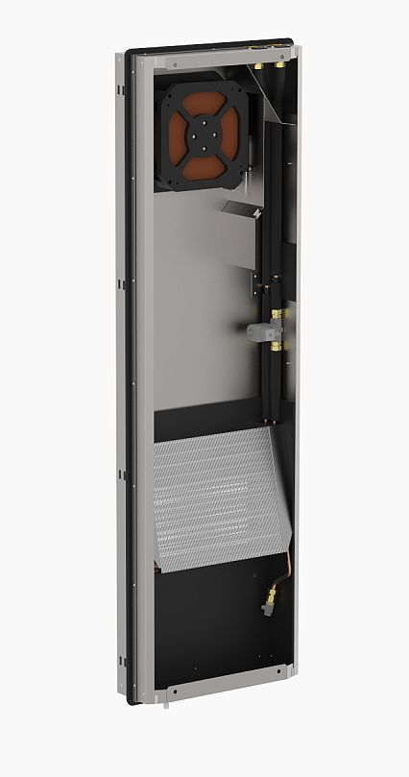

Photo caption: PWS 6502 T and PWI 6502 T have an output of up to 5 kW and a top-mounted water connection.

About Pfannenberg
Pfannenberg is a medium-sized company which provides innovative and high-quality electro-technology for industry. Today, the company belongs to the global players of this industry with its headquarters is in Hamburg, Germany and its locations in Brazil, China, England, France, Italy, Russia, Singapore and the USA. The product portfolio comprises components and system solutions for the thermal management of electrical enclosures, chillers, visible and audible signaling technology and custom solutions. A special highlight in the Pfannenberg portfolio is the designed illuminations which are commissioned by architects, designers, and urban and spatial planners (www.art-illumination.com).
You can find more information about Pfannenberg on: http://www.pfannenberg.com

Press office
Carsten Otte
c/o Technical Publicity
Bäckerstraße 6, 21244 Buchholz
Tel. +49 (0)4181 968 098-80
cotte@technical-group.com

Company contact
Ulla Wenderoth
Pfannenberg Europe GmbH
Werner-Witt-Str. 1, 21035 Hamburg, Germany
Tel. +49 (0)40-73412-317
Ulla.Wenderoth@Pfannenberg.com

