PRESS RELEASE

Compact chillers in the optimized CCE series simplify application-specific configuration

The new generation of devices makes maintenance, transport and product selection easier in a broad spectrum of industrial applications.

Hamburg, 7 September 2017. Having developed the compact chillers in the CC series further, Pfannenberg will be launching the successor generation, the CCE series, on the market. The production safety specialist will be offering combinable pre-configurations of the devices designed for different usage scenarios. This simplifies the selection process for users and allows short delivery times. The CCE chillers are available in six performance classes and two sizes providing from 1.1 to 6.5 kW of power that can serve a wide range of industrial applications.

“Our focus in developing the CCE series was to make operation and maintenance even easier," explains Uwe Eckstein, Sales Product Manager for chillers at Pfannenberg. "The predefined configuration packages improve availability and facilitate a global servicing operation. Our cost-efficient chillers allow processing systems in a very wide range of different industrial applications to be operated economically and reliably."

Pfannenberg drew on its extensive experience to develop the three configuration packages for the CCE processing chillers: Hydraulic Protection, Smart Cooling and Precision Cooling. The primary function of the Hydraulic Protection configuration is to protect the system. An adjustable flow meter sends out an alert when the flow is too low. A water-level monitor in the supply tank protects the pump in the cooling circuit from running dry and from any consequent damage. To ensure that the pressure throughout the system is optimized, there is an automatic adjustable hydraulic bypass integrated in appropriately configured devices.

The Smart Cooling configuration is designed for professional temperature monitoring and error recording. One of its functions is to manage a temperature differential relative to the ambient temperature if there are issues concerning condensation and elongation. The integrated temperature monitor issues an alert if the temperature of the coolant rises or falls unexpectedly. Using the error code shown on the display and the data captured, this configuration is the basis for rapid fault elimination and preventative maintenance measures.

The Precision Cooling configuration has been developed to limit temperature variation to a maximum of ±1K. Firstly, the hot gas bypass improves the accuracy of the temperature regulator avoiding any strain on the compressor from excessively frequent switching on and off. Secondly, a "Fan on/off" function also makes the temperature control more accurate by manipulating the performance of the condenser heat exchanger. As well as precise temperature control, another plus point of this configuration is its non-damaging mode of operation.

The new generation of CCE chillers is also more maintenance-friendly. For example, the side and front panels can be removed to facilitate access to the internal electronics without the need to dismantle the chiller. Thanks to an improved indicator on the coolant tank, the fill-level can always be read easily and operators can respond in good time if it is too low. Pre-fitted lifting brackets, which were previously only available as an option, make handling and transporting the chiller much easier.

To increase the service life of the CCE devices in a demanding industrial environment, Pfannenberg offers prefix-filters and frames, which can be fitted without tools to reduce the maintenance costs of the system. Another important factor in problem-free operation, even in a complex system, is the hydraulics circuit made entirely of non-ferrous components to reduce corrosion.

The compact chiller systems in the CCE series have many functions, which are otherwise only offered by larger models. This makes them the ideal solution for integrated motor or process cooling in high-speed processing centers. Because they operate on single-phase current, installation in most commercial and industrial environments is easy. The chillers are suitable for a wide range of applications including machine tools, plastic processing, renewable energy, the food, drink and pharmaceutical industries, printing machinery, packaging systems and welding.

Picture caption:
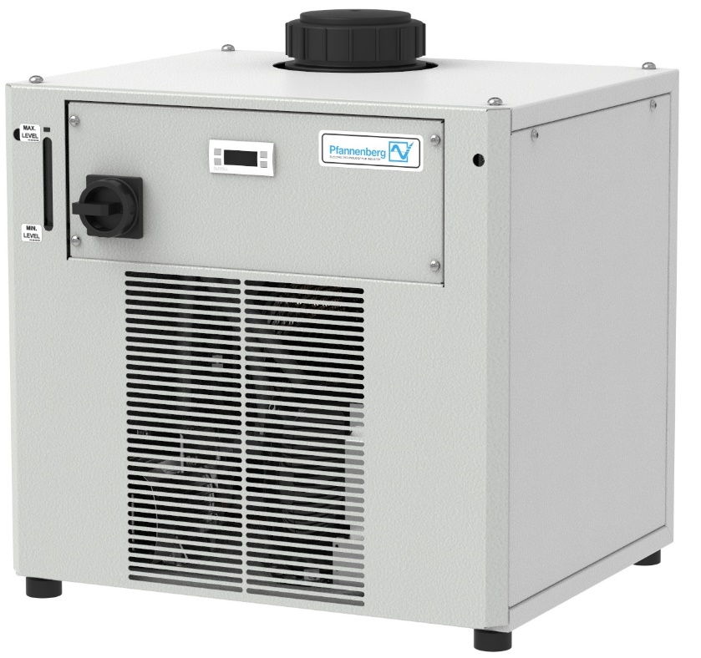
PF000884_Image1: Thanks to predefined and combinable configuration packages, the latest generation of CCE chillers from Pfannenberg are flexible, cost-efficient and can be used in a wide range of different industrial applications.

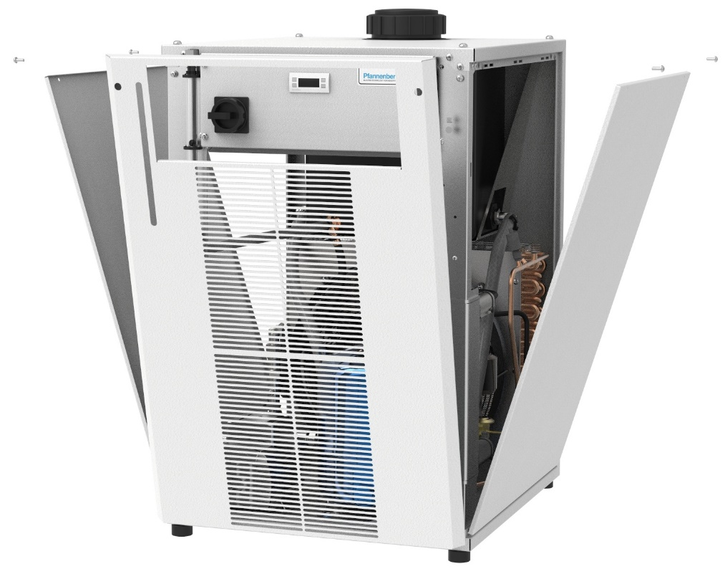

PF000884_Image2: View into an open Pfannenberg CCE chiller. Pfannenberg offers pre-assembled filters and frames which can be installed without tools, reducing the maintenance costs of the plant.

About Pfannenberg
Pfannenberg is a medium-sized company which provides innovative and high-quality electro-technology for industry. Today, the company belongs to the global players of this industry with its headquarters is in Hamburg, Germany and its locations in Brazil, China, England, France, Italy, Russia, Singapore and the USA. The product portfolio comprises components and system solutions for the thermal management of electrical enclosures, chillers, visible and audible signaling technology and custom solutions. A special highlight in the Pfannenberg portfolio is the designed illuminations which are commissioned by architects, designers, and urban and spatial planners (www.art-illumination.com).
You can find more information about Pfannenberg on: http://www.pfannenberg.com

Press office
Carsten Otte
c/o Technical Publicity
Bäckerstraße 6, 21244 Buchholz
Tel. +49 (0)4181 968 098-8
cotte@technical-group.com

Company contact
Ulla Wenderoth
Pfannenberg Europe GmbH
Werner-Witt-Str. 1, 21035 Hamburg, Germany
Tel. +49 (0)40-73412-317
Ulla.Wenderoth@Pfannenberg.com

