PRESS RELEASE

Thermal management with intelligent device monitoring for electrical enclosures

Working with partners SICK and Cybus, Pfannenberg presents a new M2M communication solution for thermal management devices for electrical enclosures

Hamburg, 11 October 2017. At this year's SPS IPC Drives trade fair in Nuremberg, the electronics specialist Pfannenberg will be presenting communication-enabled thermal management devices for electrical enclosures. This year for the first time, Pfannenberg in collaboration with the leading sensor manufacturer SICK will be showing how the SICK Meeting Point Router (MPR) can be used for monitoring and servicing cooling devices remotely from any location. From 28 to 30 November in Hall 5 at Stand 339 visitors will be able to see for themselves what modern M2M device monitoring can deliver and find out about the benefits it offers users. CCE series chillers will also be on show at the trade fair. These compact devices are exceptionally easy to maintain and can be used in a wide range of industrial applications.

Nils Halm, CTO Pfannenberg Group, welcomes the partnership with SICK: "The MPR allows remote maintenance of our communication-enabled cooling devices from any location. The connection is via a Modbus RTU interface and a Modbus TCP/IP converter. Data from the SICK Remote Service Platform can be accessed directly through a defined software interface produced by our partner Cybus and then visualized. Secure transmission of the data is paramount."

The MPR is based on an industrial PC with two Ethernet interfaces which serves to physically separate the machine and customer networks. An integrated firewall enables communications pathways between the customer network and the machine network and between the machine network and the Internet only when they are actually needed. Log book entries keep a record of all the accesses in the machine folder. It is user-friendly: the remote monitoring facility can be activated and securely terminated via a touch screen.

Compact and communication-enabled cooling devices
The εCool X series is further evidence of Pfannenberg's expertise in the area of communication-enabled cooling devices. These thermal management devices for electrical enclosures can be integrated directly in the user's automation systems. The multimaster function of these controllers ensures that the temperature remains constant, even in large groups of electrical enclosures, by operating several cooling devices simultaneously. A service interface allows external parameterization and the fault memory to be read via a PC. If required, they can also provide relevant device parameters via the Cloud for remote maintenance. Users benefit from customized maintenance, cost-efficient service and better machine availability thanks to preventative servicing.

Top-mounted water connection for new air/water heat exchangers
The 5 kW PWI 6XXX T air/water heat exchangers are a new entry in the portfolio.
They are designed for partially recessed mounting and also have a water connection positioned on the top. Water supply systems in factories are frequently fitted at an approximate height of 2 meters to protect them from operations at ground level where they could be trodden on accidentally or damaged by forklifts, for example. This risk is avoided by the new position of the connections. An optional kit with cover panels is available with which to adapt the appearance of the PWI to the machine design.

CCE chillers: Compact, maintenance-friendly and versatile
Having developed the compact chillers in the CC series further, Pfannenberg is launching the successor generation, the CCE series, on the market. The CCE chillers are available in six performance classes and two sizes, providing from 1.1 to 6.5 kW of power, and in pre-configurations which can be combined with each other depending on the requirements of the situation in which the devices are used. This simplifies the selection process for users and allows short delivery times. The compact chiller systems in the CCE series are exceptionally maintenance-friendly and have many functions which are otherwise only offered by larger models. The chillers are suitable for a wide range of applications including machine tools, plastic processing, renewable energy, the food, drink and pharmaceutical industries, printing machinery, packaging systems and welding.

Presentation of the NEMA 3R/4/4X weather protection hood for filter fans
There is a new weather protection hood for filter fans with NEMA 3R/4/4X protection classification. Pfannenberg filter fans in RAL 7035 and RAL 9011 will also be exhibited. They are available with IP 54 and IP55 protection classification and have UR and UL licenses. In combination with the new weather protection hood they are ideal for use in applications with stringent hygiene requirements and anywhere where water sprays are used for cleaning, in the food and drink industry, for example.

Pfannenberg's 3D-Coverage: Signaling device performance visualized
Pfannenberg 3D-Coverage is a new practical method of visualizing in a 3D graphic the actual performance of audible and visual signaling devices in a given space, taking real environmental conditions into account. This allows planners to optimize the configuration of the signaling solutions. The method offers certain protection from incorrect dimensioning, reliable compliance with industrial norms and regulations and optimum cost efficiency. By integrating 3D-Coverage with the free online planning tool Pfannenberg Sizing Software (PSS), it is possible to calculate individual values. Furthermore, it provides an informed recommendation for the ideal signaling devices and their positioning, making it even easier for users to find the best signaling solution for them.

Strong and stable: DNV-GL-certified signaling devices
DNV-GL-certified signaling devices from Pfannenberg are the right solutions for tough industrial applications where they will be exposed to strong vibration, continuous jarring or heavy impact. The award of a DNV-GL certificate guarantees that the signaling devices are of the highest quality and reliability, not only in the maritime sector but also in many extremely tough industrial environments – in heavy industry, the processing industries, logistics or railways and goods transport, for example. Because they are very effective, the audible signaling devices, for instance, ensure that the workforce is sure to be warned or alerted even if the environment is very noisy.

Multifunction LED lights for industrial applications
The QUADRO LED-HI multifunctional light will also be on show on the Pfannenberg stand. This light is used for the visual signaling of hazardous situations and to indicate the status or fill level of machines and systems. The optical signals of the light are created with LEDs with a high level of luminous efficacy. Modular in design and multifunctional, it offers manufacturing companies, industrial installation and service firms, mechanical and systems engineering companies and the producers of lifting equipment and their service departments a cost-efficient, versatile and powerful signaling solution. Thanks to robust mechanical construction and categorization in high protection classes (IP66, IP67 and IK08), the QUADRO LED-HI is suitable for indoor and outdoor use.

PYRA L: A powerful addition to the PYRA series
The new PYRA L ("Large") signaling device is an addition to the tried and trusted PYRA series for visual and visual/audible alerting in machine safety and fire and gas alerting applications. With a coverage volume of up to 15 m (ceiling height), it is a more powerful addition to the existing range. The PYRA L signaling device is available as a flashing XENON light and as a sounder/flashing Xenon light combination.

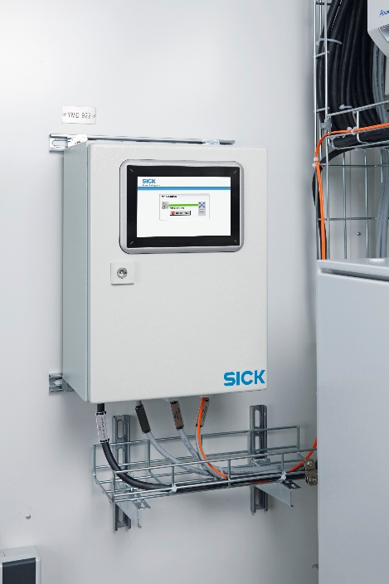
Photo caption: The Meeting Point Router (MPR) from SICK allows the communication-enabled cooling devices from Pfannenberg to be serviced remotely from any location. Image © SICK AG.

About Pfannenberg
Pfannenberg is a medium-sized company which provides innovative and high-quality electro-technology for industry. Today, the company belongs to the global players of this industry with its headquarters is in Hamburg, Germany and its locations in Brazil, China, England, France, Italy, Russia, Singapore and the USA. The product portfolio comprises components and system solutions for the thermal management of electrical enclosures, chillers, visible and audible signaling technology and custom solutions. A special highlight in the Pfannenberg portfolio is the designed illuminations which are commissioned by architects, designers, and urban and spatial planners (www.art-illumination.com).
You can find more information about Pfannenberg on: http://www.pfannenberg.com

Press office
Carsten Otte
c/o Technical Publicity
Bäckerstraße 6, 21244 Buchholz
Tel. +49 (0)4181 968 098-80
cotte@technical-group.com

Company contact
Ulla Wenderoth
Pfannenberg Europe GmbH
Werner-Witt-Str. 1, 21035 Hamburg, Germany
Tel. +49 (0)40-73412-317
Ulla.Wenderoth@Pfannenberg.com

