PRESS RELEASE

An evolutionary step forward for communication-enabled thermal management devices

New M2M communication solution for εCool X series thermal management devices / Pfannenberg working with partners SICK and Cybus

Hamburg, 28 November 2017. Electronics specialist Pfannenberg has developed communication-enabled thermal management devices which allow intelligent device monitoring for electrical enclosures. The communications-enabled cooling devices in the εCool X series can already be integrated directly into the automation systems of the users since 2015. The evolution continues: in collaboration with the leading sensor manufacturer SICK, Pfannenberg is now presenting a new M2M communication solution, which can be used for monitoring and servicing cooling devices remotely from any location made possible by the SICK Meeting Point Router (MPR). All relevant status, diagnostic and alarm conditions can thus be made available as physical parameters. Users benefit from application-specific maintenance, cost-efficient service and increased machine availability thanks to preventive maintenance.

Nils Halm, CTO Pfannenberg Group, welcomes the partnership with SICK: "The MPR allows remote maintenance of our communication-enabled cooling devices from any location. The connection is via a Modbus RTU interface and a Modbus TCP/IP converter. Data from the SICK Remote Service Platform can be accessed directly through a defined software interface produced by our partner Cybus and then visualized. Secure transmission of the data is paramount."

MPR for secure communications
The MPR is based on an industrial PC with two Ethernet interfaces which serves to physically separate the machine and customer networks. An integrated firewall enables communications pathways between the customer network and the machine network and between the machine network and the Internet only when they are actually needed. Log book entries keep a record of all the accesses in the machine folder. It is user-friendly: the remote monitoring facility can be activated and securely terminated via a touch screen.

Communication-enabled cooling devices allow predictive maintenance
Pfannenberg’s εCool X-Serie allows to access live and from anywhere useful device parameters. Users can monitor the cooling devices for their electrical enclosures more efficiently, taking a predictive approach (predictive maintenance) which results in improved machine and system availability. For example, a control lamp shows when wear is becoming apparent which users can deal with in routine or predictive maintenance. Furthermore, it signals various statuses and alarms, such as "device running", "door open" or "high temperatures detected externally or internally". These status reports can be used to warn the operator or can be integrated in the automated control units of modern production systems. The analysis of thermal loads over a longer period also allows maintenance intervals to be determined exactly in line with the conditions prevailing at the location where the device is used.

Furthermore, temperatures and speeds of individual components, such as compressors or fans can be logged. The long-term analysis of this data can reveal, for example, that the device is continuously running at threshold levels and the amount of cooling calculated is possibly insufficient. Users can respond in good time and prevent potential machine downtime.

The communications-enabled cooling devices in the εCool X series feature controllers with multimaster functions. They ensure that the temperature remains constant, even in large groups of electrical enclosures, by operating several cooling devices simultaneously.

The cooling devices in the εCool X series are cut-out-compatible with Pfannenberg's air/air and air/water heat exchangers and with existing devices in the same series. This means that users can easily upgrade to the communication-enabled version without any mechanical intervention.

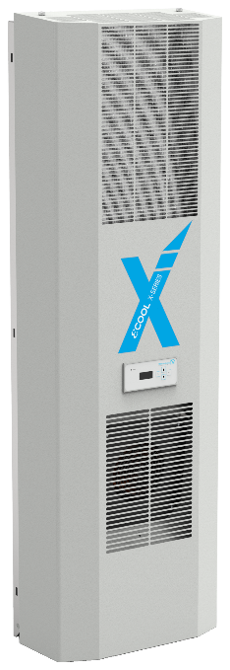

Photo Caption: The cloud-ready X-series cooling device with Premium controller increases efficiency by up to 200 %

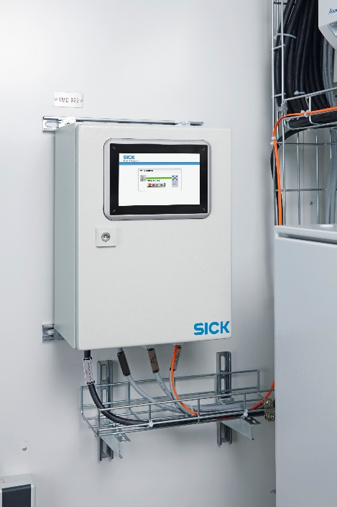

Photo caption: The Meeting Point Router (MPR) from SICK allows the communication-enabled cooling devices from Pfannenberg to be serviced remotely from any location. Image © SICK AG.

About Pfannenberg
Pfannenberg is a medium-sized company which provides innovative and high-quality electro-technology for industry. Today, the company belongs to the global players of this industry with its headquarters is in Hamburg, Germany and its locations in Brazil, China, England, France, Italy, Russia, Singapore and the USA. The product portfolio comprises components and system solutions for the thermal management of electrical enclosures, chillers, visible and audible signaling technology and custom solutions. A special highlight in the Pfannenberg portfolio is the designed illuminations which are commissioned by architects, designers, and urban and spatial planners (www.art-illumination.com).
You can find more information about Pfannenberg on: http://www.pfannenberg.com

Press office
Carsten Otte
c/o Technical Publicity
Bäckerstraße 6, 21244 Buchholz
Tel. +49 (0)4181 968 098-80
cotte@technical-group.com

Company contact
Ulla Wenderoth
Pfannenberg Europe GmbH
Werner-Witt-Str. 1, 21035 Hamburg, Germany
Tel. +49 (0)40-73412-317
Ulla.Wenderoth@Pfannenberg.com

